SYSC 3310

Group Project

TFTP Protocol w/ ERROR Check

Team 2

Loo Ben

Nguyen Andrew

Morrissette Eric

Palko Ben

Date: March 10th 2018

Table of Content

|  |  |
| --- | --- |
| Topics | Pages |
| Iteration Deliveries  Timing Diagram ERROR Codes  Iteration 0  File Transfer without ERROR Detection and Correction  Iteration 1  File Transfer without ERROR Detection and Correction  Iteration 2  ERROR Packets Checking 1  ERROR Packets Checking 2  ERROR Packets Checking 3  ERROR Packets Checking 6  Iteration 3  Timeout/Retransmission  Iteration 4  ERROR Packets Checking 4  ERROR Packets Checking 5  Iteration 5  File Transfer between Different Computers  Breakdown Responsibilities  Diagrams  UCMs for Read/Write w/ Error Simulator  UML Class Diagram  Setup and Troubleshoot  Setup and Test Instructions  Test Table  Source Code |  |

Timing Diagram ERROR Codes

ERROR Codes

0 Not defined, see ERROR message (if any).  
1 File not found.  
2 Access violation.  
3 Disk full or allocation exceeded.  
4 Illegal TFTP operation.  
5 Unknown transfer ID.  
6 File already exists.  
7 No such user.

Iteration 2

Timing Diagrams for ERROR Code (1, 2, 3, 6)

[ERROR Code 1] – File not found

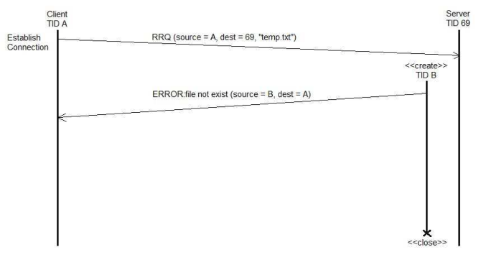

1. Client sends read request to destination 69 server
2. “temp.txt” file does not exist
3. Server sends an ERROR (1) packet to client (“ file not exist”)
4. Server closes socket
5. Client prints out ERROR (1) on server packet. Sent file “temp.txt” does not exist

[ERROR Code 2] – Access Violation

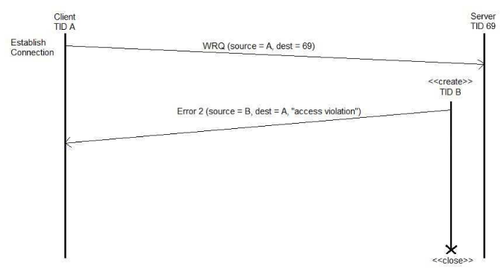

1. Client sends a write request to destination 69 server
2. Server traced client not having insufficient privileges to write.
3. Server sends an ERROR (2) packet to client (“access violation”)
4. Server closes packet
5. Client prints out ERROR (2) on server packet. Write was not successful, access violation

[ERROR Code 3] - Disk full or allocation exceeded

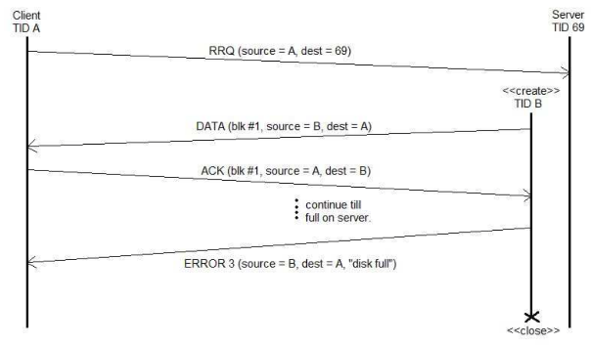

1. Client sends a read request to destination 69 server
2. Server successfully received the request and sends DATA packet (blk #1)
3. Client successfully received the DATA and sends an ACK (blk #1)
4. Step 2 and 3 occurs till the disk is full on server
5. Server sends an ERROR (3) packet to client (“disk full”)
6. Server closes packet
7. Client deletes the file that was not successful in completion
8. Client prints out ERROR (3) on server packet. Server disk full or allocation exceeded

[ERROR Code 6] – File already exists

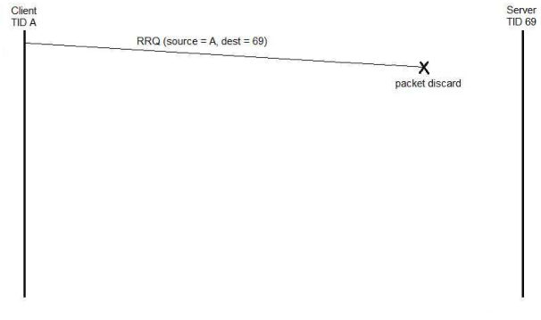

1. Client sends a read request to destination 69 server
2. Client finds existent DATA file
3. Client discards the packet transmission
4. Client prints out ERROR (6). File already exist